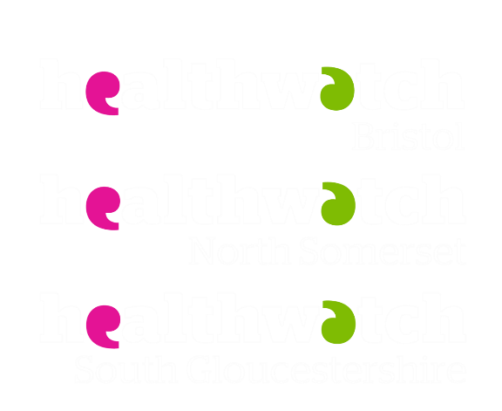

How-to guide
Online health services

CONTENTS

Finding health advice online 2

NHS App 3
Create an NHS login 3
Prove who you are with registration details from your GP practice 7
Prove who you are using photo ID 11
eConsult – online consultation 15
Book a GP appointment 19
Additional GP services 22
NHS eReferral service 25
Prescriptions 26
Viewing your medical health records 29
Additional support 30

Finding health advice online

Recommended health websites:
- The NHS website – www.nhs.uk
- UK’s biggest health website – no need to register
- Comprehensive A-Z of health conditions, symptoms and treatments, including what to do and when to get help
- Advice on good health and wellbeing
- Find local NHS services

- Patient – www.patient.info
- A comprehensive website of evidence-based clinical information
- Created by trained medical professionals and undergoes a strict peer review process
- Broad range of topics, treatments and resources
When looking for health advice online, ask yourself WWW:
Who wrote/published the information you’re reading? Ask yourself about the purpose and potential bias of the source. For example, is the site designed to provide information, or is it trying to sell you something? A reliable site will provide a ‘Contact us’ section and/or an ‘About us’ page. If a website doesn’t have either, be wary.
What content is published on the site? Does the site base its information on relevant, factual research? Does it say where it got its information from? Check when it was last updated. A reliable site will be monitored and updated regularly.
Where has the information on the site come from? Certain information might not be relevant if it relates outside the UK. Check the site’s web address to get an idea of the site’s country of origin. It will also help to reveal the kind of organisation that produced it.
- .org = Not-for-profit organisation
- .uk = United Kingdom site
- .gov = Government site
- .edu = Educational institution (e.g. a university)
- .com = Commercial business
Tips for searching for health information
- Don’t take information at face value if it’s from a source you haven’t heard of before. Check it with another website.
- Talk with your health or social care professional if you are unsure about the information you have read.
- Be cautious of sites that make health claims that seem too good to be true.
- Be wary of information that promises quick, dramatic or miraculous results.

NHS App

Create an NHS login

- Open the NHS App on your smartphone/tablet or visit the NHS website and access your NHS account by clicking on ‘My Account’ in the top right corner of the screen.

NHS App on a smartphone/tablet (you can download it from the App Store or Google Play store)

Accessing your NHS account through the NHS Website (www.nhs.uk)

- Click ‘Continue with NHS login’.
- You will need an email address, a phone which receives texts, and ideally your NHS number to register.
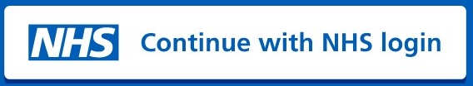

- Enter your email address and click ‘Continue’.

- Create a password and click ‘Continue’.
- You will have to input this twice to ensure you have correctly entered your intended password.
- Password must be a minimum of 8 characters long, have at least 1 UPPERCASE letter and not contain spaces.
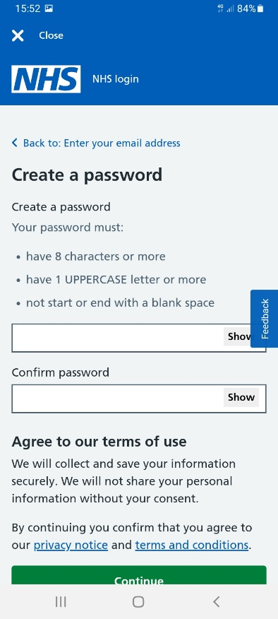

- Check your email account for an email from the NHS with your 6-digit security code (it may have gone into your junk folder).

- Enter the security code into the app to verify your email address and click ‘Continue’.
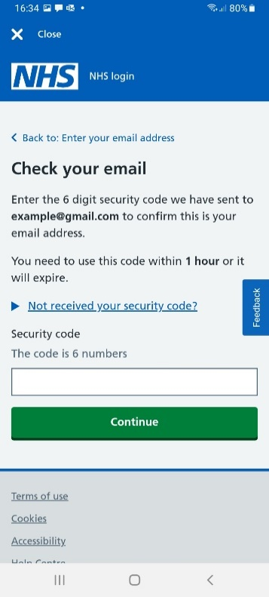
- This step makes sure you have entered the correct email address.

- Enter your mobile phone number and click ‘Continue’.
- Another 6-digit security code will be sent to your phone by text.
- Enter the 6-digit security code sent by text to your phone into the box and click ‘Continue’.

- Select ‘Yes, I know my NHS number’ or ‘No, continue with my full name’, depending on whether you know your NHS number.
- You can still set up your NHS login if you don’t know your NHS number.
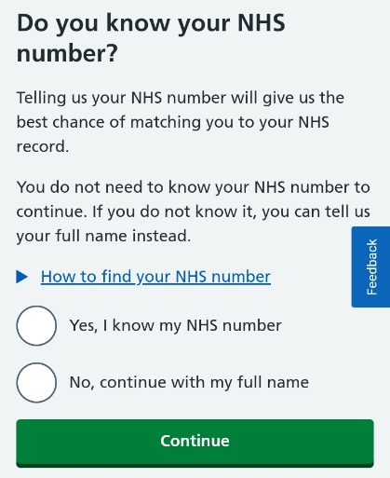

Skip to step 12 if you have entered your NHS number.

- Enter your full name (click on each box to fill in) and click ‘Continue’.

- Enter your date of birth (click on each box to fill in) and click ‘Continue’.

- Enter your postcode (click on the box to fill in) and click ‘Continue’.

- Check your details and click ‘Submit information’ if they are correct.
- Click ‘Change name’, ‘Change date of birth’ or ‘Change postcode’ before submitting your information if any of your details are incorrect.

- Accept the conditions of use. Scroll to the bottom to select that you understand and accept the terms of use and privacy policy and click ‘Continue’.

- Select whether you would like to receive direct notifications from the app to your phone. This includes messages from your GP and appointment reminders.

You have now successfully finished setting up your NHS login. The following section will focus on confirming your identity to connect the app to your GP practice.

Prove who you are with registration details from your GP practice
Once you have created a login, you will need to confirm your identity to get full access to your NHS account to book appointments, order repeat prescriptions and view your medical records.
There are two ways to confirm your identity. Using registration details or using photo ID - see page 11). The most straightforward is to ask the reception staff at your GP practice for your “Registration details for Online Health Services” form. You may need to complete a short form and show proof of your identity. The staff will then give you a form with your Linkage Key (could be called Passphrase), ODS code (Organisation Code or Practice I.D.) and Account ID. They may print it out straight away, post it to you or email it to you.
- Once you have created a login, you will be directed to the ‘Home’ screen. Select ‘Continue’ on the blue ‘Prove your identity to get full access’ box.
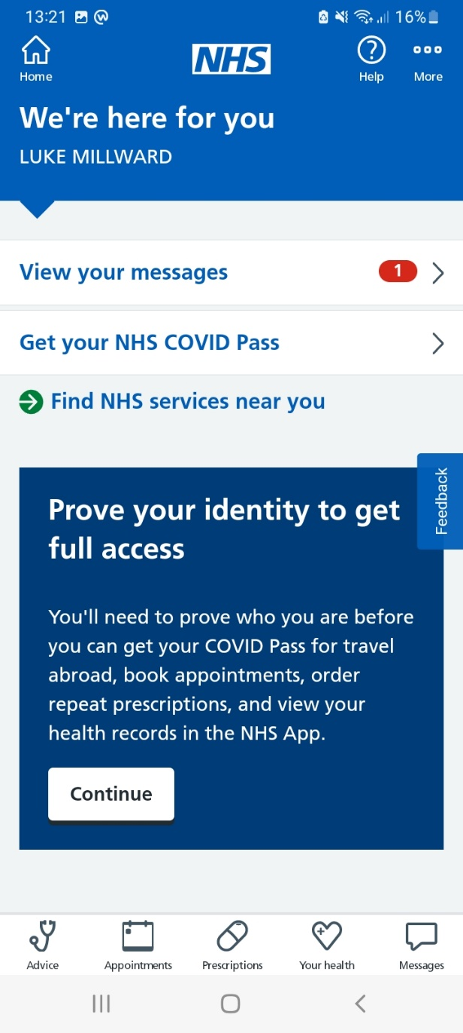

- Confirm your personal details and click ‘Continue’.

- Click ‘Continue’ when a message about proving who you are appears.

- Click ‘No, I do not have photo ID’ and click ‘Continue’.
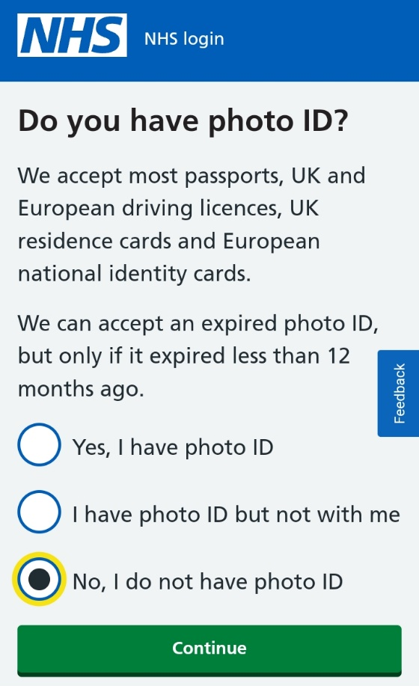

- Select ‘Yes – I use online services’ and click ‘Continue’.
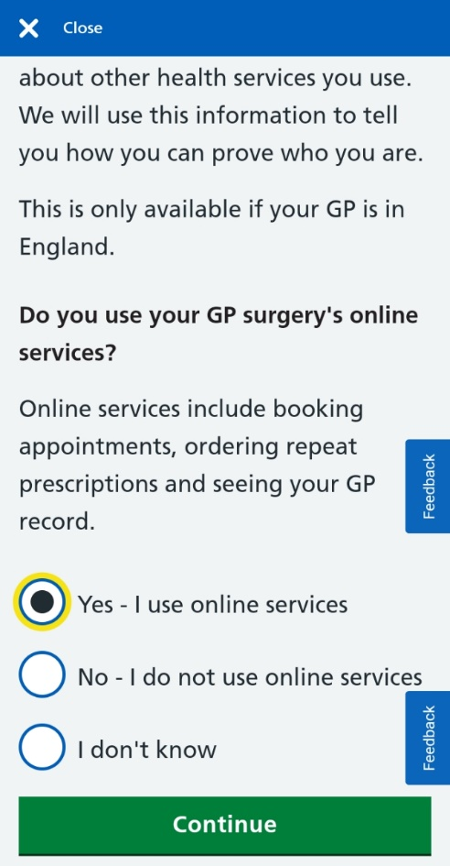

- Select ‘Yes – I have all 3 details’ and click ‘Continue’.
- If you do not have the 3 registration details, you need to contact your GP practice first.
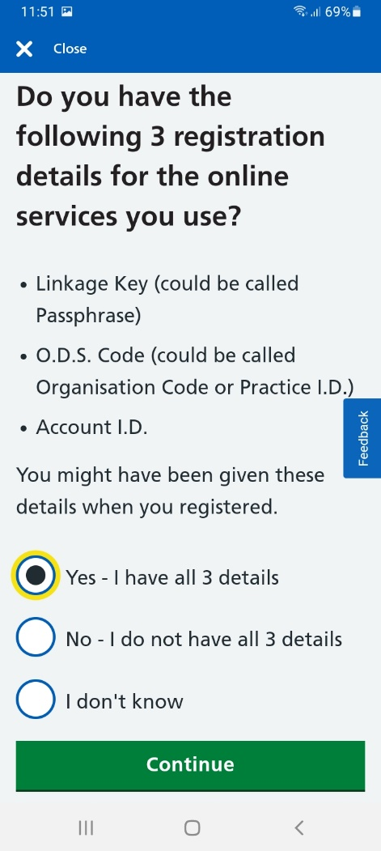

- Select each box and insert your Linkage Key, O.D.S Code and Account I.D. then click ‘Continue’.
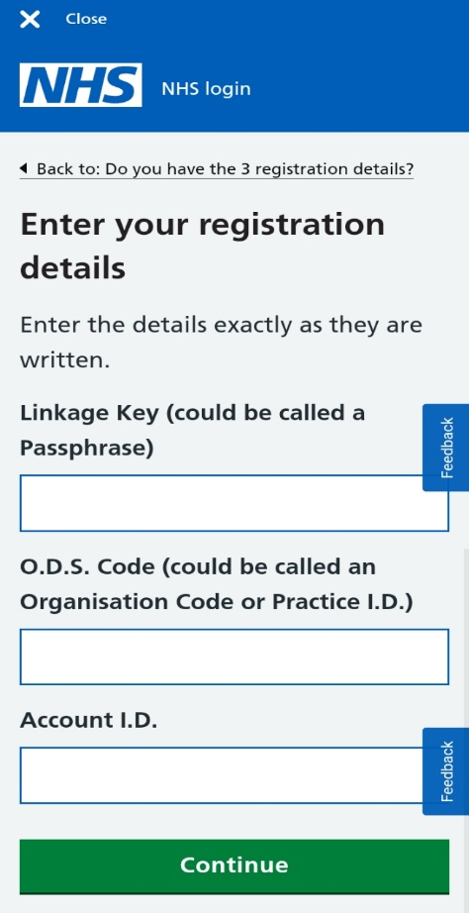

- Enter your date of birth (click on each box to fill in) and click ‘Continue’.

- Enter your postcode and click ‘Continue’.

- Select either ‘Yes’ or ‘No’ when asked whether you know your NHS number.
- You do not need your NHS number to finish connecting your account to your GP practice.

Look out for an email to confirm it’s been successful. It may take a few hours to receive this. Check your junk/spam folder if you haven’t received it within 24 hours.

Prove who you are using photo ID

Once you have created a login, you will need to confirm your identity to get full access to your NHS account to book appointments, order repeat prescriptions and view your medical records.
If you have not been able to visit your GP practice for your registration details for online services, you can link your NHS account using photo ID.
Accepted IDs include:
- Passport
- UK Driving Licence
- Full European Driving Licence
- European National Identity Card
- UK residence-card or biometric residence permit (BRP)
The app accepts expired photo ID if it expired less than 12 months ago.

- Once you have created a login, you will be directed to the ‘Home’ screen. Select ‘Continue’ on the blue ‘Prove your identity to get full access’ box.
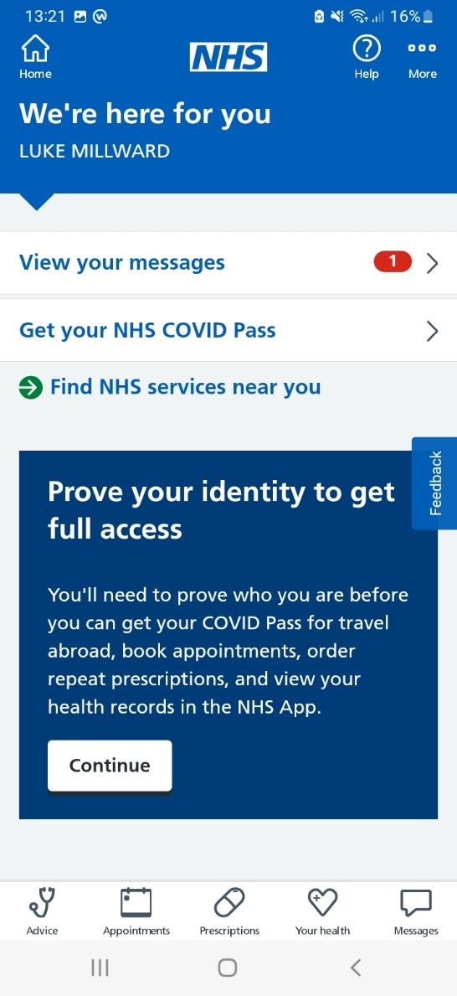

- Confirm your personal details and click ‘Continue’.

- Click ‘Continue’ when this message appears.

- Click ‘Yes, I have photo ID’ and click ‘Continue’.
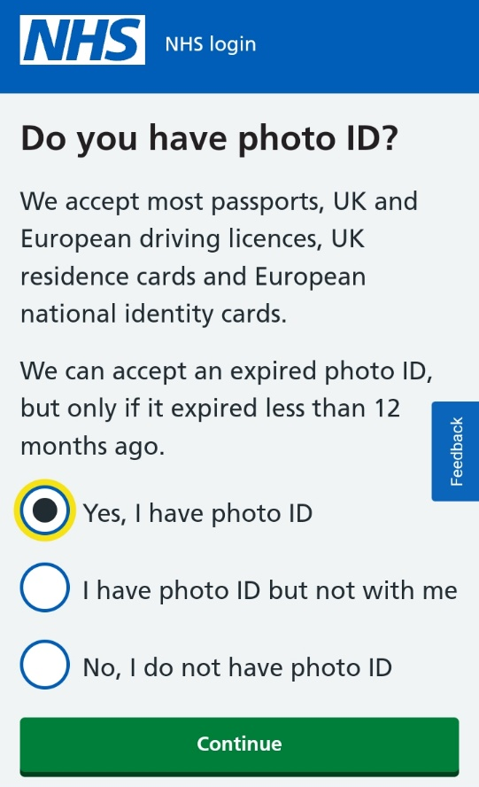

- Click ‘Continue’ on the box which says ‘Send a photo of your ID’

- Select which type of photo ID you would like to upload and click ‘Continue’.
- If you want to use a UK residence card or BRP, select ‘Other photo ID’ and then ‘European national identity card’.
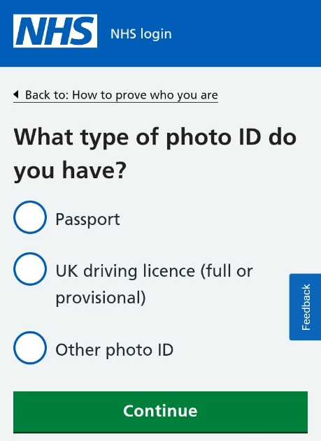
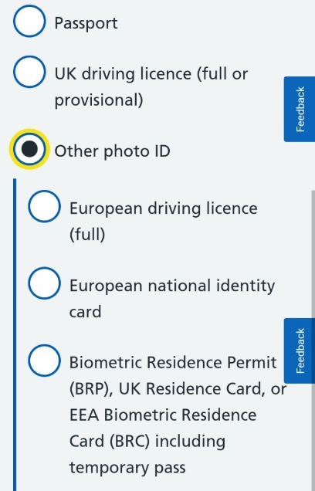

- Choose either ‘Take a photo now’ to use the camera on your device or choose ‘Upload a photo’ if you already have a photo on your device. Then click ‘Continue’.

7a. If using your camera, click ‘Open Camera’ and take a photo of your ID.
- A message may pop-up asking you to allow access to the NHS App to take a picture. Select ‘Allow’.

7b. If uploading a photo, click ‘Open Photo Library’.
- A message may pop-up asking you to allow access to the NHS App to open your phone’s gallery. Select ‘Allow’.
- Answer the questions checking the visibility of your picture. Click ‘Continue’ after answering each question and click ‘Submit’ once you’ve responded to all the questions.

- Next, you’ll need to record your face using your device so the app can match you to your photo ID. Click ‘Continue’ on the box which says ‘Record your face’.

- You may be asked to either scan your face or record a video repeating a series of 4 numbers which will be displayed on the screen.
- You can say the 4 numbers, sign the numbers using British Sign Language, or write the numbers down and show them instead.

- It may take a couple of hours to confirm. You will receive an email once your account has been linked to your GP practice.
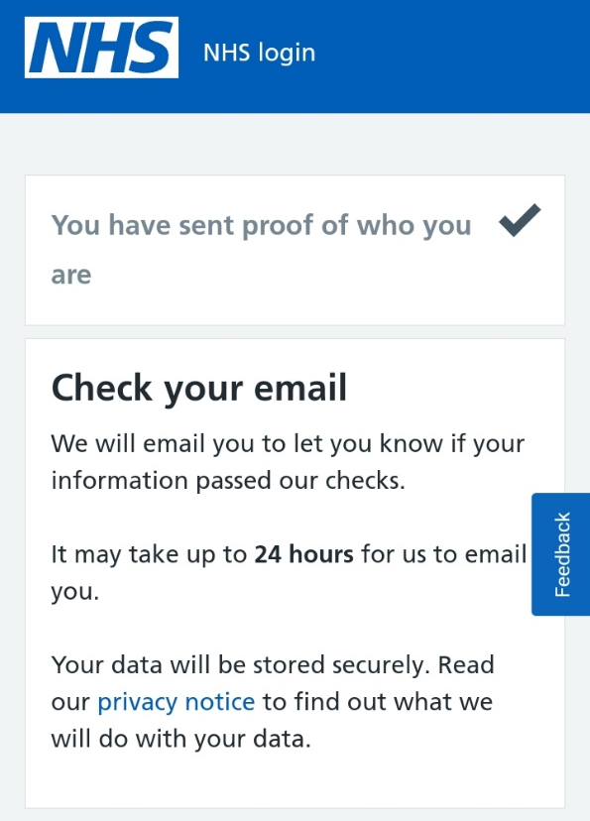

eConsult – online consultation

Some GP practices may not have this service turned on or may only have it turned on for specific hours during working days. You can use eConsult to ask your GP practice about your health symptoms, conditions or treatments. It may take up to two working days to recieve a response.
- Click ‘Advice’ on the navigation bar.
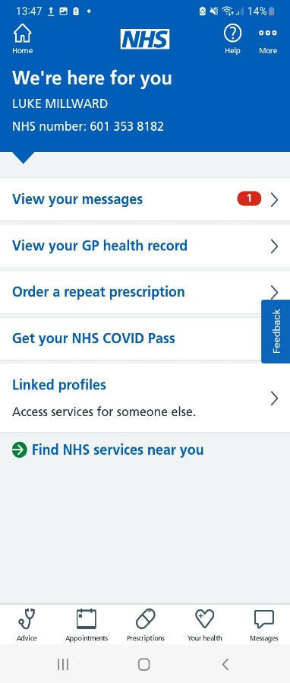

- Click ‘Ask your GP for advice’.
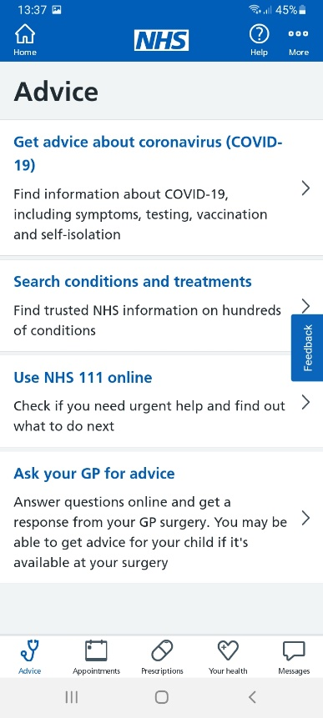

- Select whether you would like the app to use your name, DOB, NHS number and postal address with the online consultation service and click ‘Continue’.
- This will save you from typing in your personal details later.
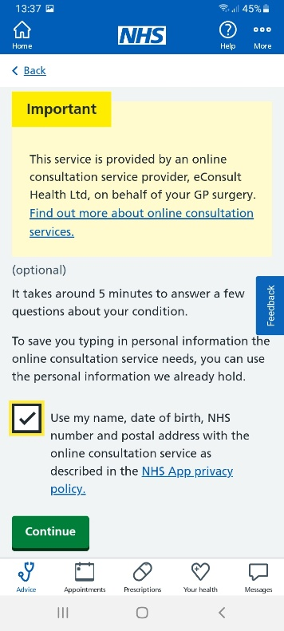

- Select whether you are asking for help for yourself or your child and click ‘Continue’.

- Agree to the privacy notice applicable to online consultation services.
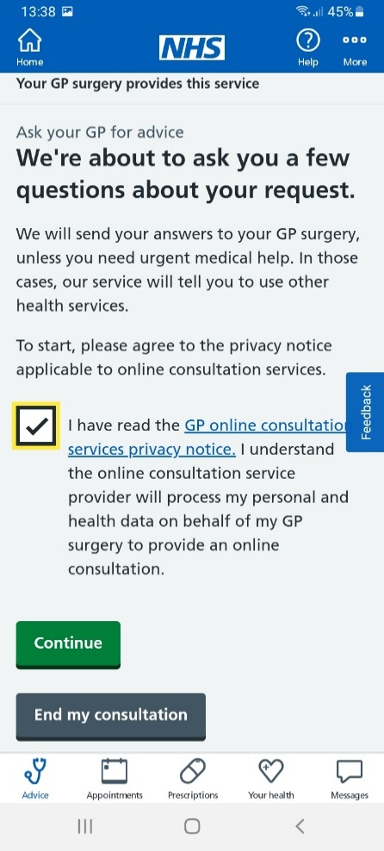

- Choose which condition you are seeking advice for from the list.
- You may have to take your time scrolling down to find your condition.
- If you cannot find your condition, scroll to the bottom of the page and choose ‘I cannot find my condition’.

- Read the information to make sure your condition isn’t an emergency and confirm you aren’t experiencing any of these symptoms. If you are experiencing any of the listed symptoms, stop using the NHS App and ring 999.

- Choose your sex and click ‘Continue’.

- The next steps will differ depending on which condition you are enquiring about. Usually, write in a few words how the GP practice can help/what advice you seek. You will usually be asked a few further questions about your symptoms/condition/treatment.

Your practice may respond by phone, text or email.
Calls from the practice may display as ‘Blocked’, ‘No caller ID’ or ‘Private Number’.
Emails may go to your junk folder.

Book a GP appointment
Your GP practice decides what appointment types are available, and not every practice offers this service. It is not possible to book urgent GP appointments via the NHS App.
If ‘No appointments available to book online at this time’ appears, you will have to contact your GP practice via phone to book an appointment. Alternatively, use eConsult (section before) to ask your GP for advice.

- Log in to the NHS App.

- Go to ‘Appointments’ on the navigation bar.

- Select ‘GP surgery appointments’
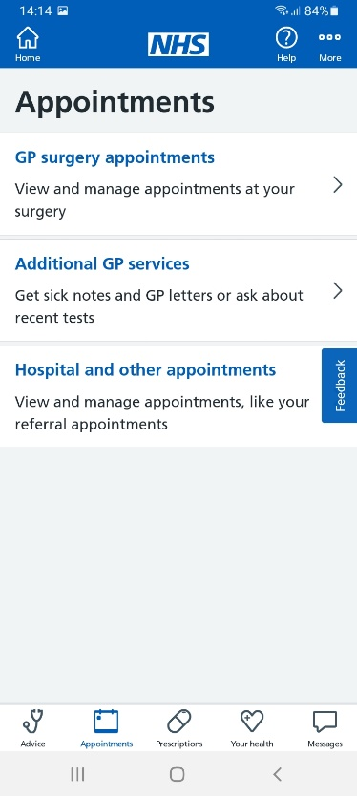

- Click ‘Book an appointment’. If you have any booked appointments at the GP practice they should appear here.
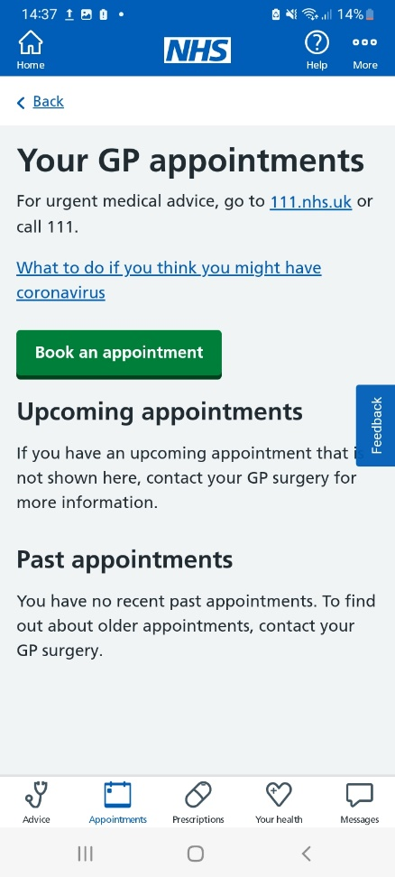

- Choose the type of appointment from the drop-down menu in the first box.

- Choose the location of your appointment in the second drop-down box.

- Click the blue + next to the available dates to choose the time of your appointment.
- Once you have selected a date and time, a confirmation prompt will appear showing the date and time you have selected, with details about the appointment type.

- Give a reason for the appointment then click ‘Confirm’.

- You should receive a text or e mail confirming the details of the booked appointment.

If the appointment time you selected is now showing as unavailable, someone else may have booked your preferred appointment slot before you finished your booking. If this happens, try to search again or alternatively use eConsult (outlined in section before).

Additional GP services

Additional GP services available through the app include discussing a recent test and requesting a sick note, GP letter, medical report, medical examination or other documents/paperwork.

- Log in to the NHS App

- Go to ‘Appointments’ on the navigation bar.

- Click ‘Additional GP Services’.

- Select whether you would like the NHS App to use your name, DOB, NHS number and postal address with the online consultation service and click ‘Continue’.
- This is secure and only used to save you time filling in personal details later.

- Select whether you are asking for help for yourself or your child and click ‘Continue’.

- Confirm you have read the GP online consultation privacy notice by pressing the box asking that you’ve read the notice and click ‘Continue’.

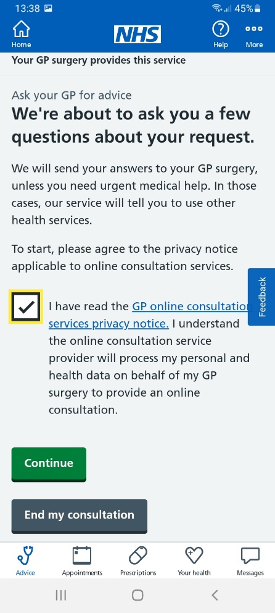

- Confirm you’re not requesting advice or treatment for a medical problem by pressing the box next to the message ‘I confirm I’m not requesting advice or treatment for a medical problem’ and click ‘Continue’.

- Confirm your sex and click ‘Continue.’

- Choose which service you’d like to request help with and click ‘Continue’.
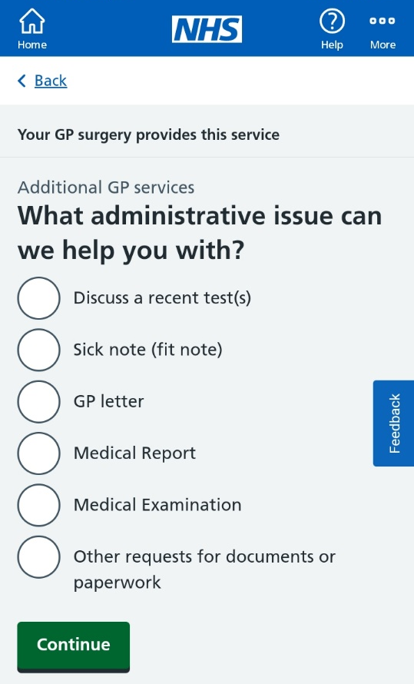

- Follow the prompt depending on the service you require.

NHS eReferral service

If you’ve been referred to a hospital specialist through the NHS e-Referral Service, you can use the NHS App to manage your first appointment.

- Log in to the NHS App

- Go to ‘Appointments’ on the navigation bar.

- Click ‘Hospital and other appointments’.

- Select ‘Book or cancel your referral appointment’.

- Find the referral appointment you’d like to book and select ‘Choose an appointment’.

- Find the clinic you’d like to attend and choose ‘Select this appointment’.

- Find date and time and click ‘Select appointment’.

- Check details and select ‘Book appointment’.

If you need to cancel your appointment, follow steps 1-4. Select the details of your appointment and click ‘Cancel appointment’. You will have to select a reason for cancelling.

Prescriptions

It is recommended that you reorder your repeat prescriptions up to 7 days before it is due to run out to allow them to be processed on time (remember, bank holidays can affect processing times).
You may not be able to order some prescription items if:
- You need a medicine review
- It’s too early to order your medicine
- It’s an acute or one-off prescription
- It has already been requested or you have a repeat dispensing prescription

- Log in to the NHS App and select the ‘Prescriptions’ on the navigation bar.

- Click on ‘Order a prescription’ to start the process.

- Choose whether it is a ‘Repeat prescription’ or a ‘Non-repeat prescription’ and click ‘Continue’.
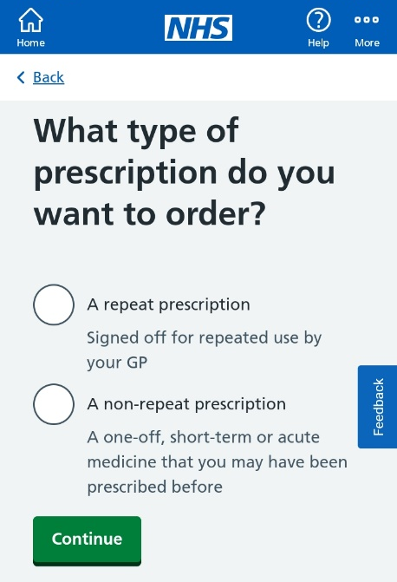

- Confirm which pharmacy you want to have your prescription sent to.
- If you have not chosen your preferred pharmacy or wish to change it, you will be asked to enter a postcode to help find the closest pharmacies to your preferred pick-up location.
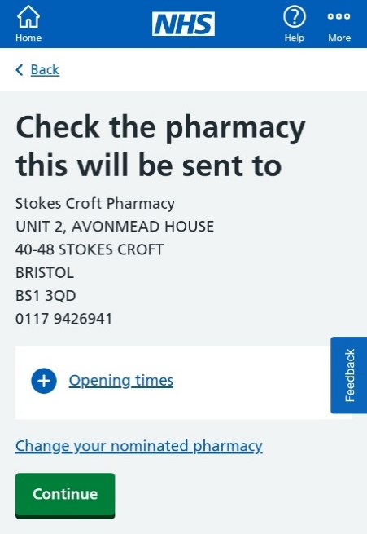

- Select all the medication you would like to order by clicking on the box next to the available medications.
- If you select the wrong medication, click the box again to unselect it.
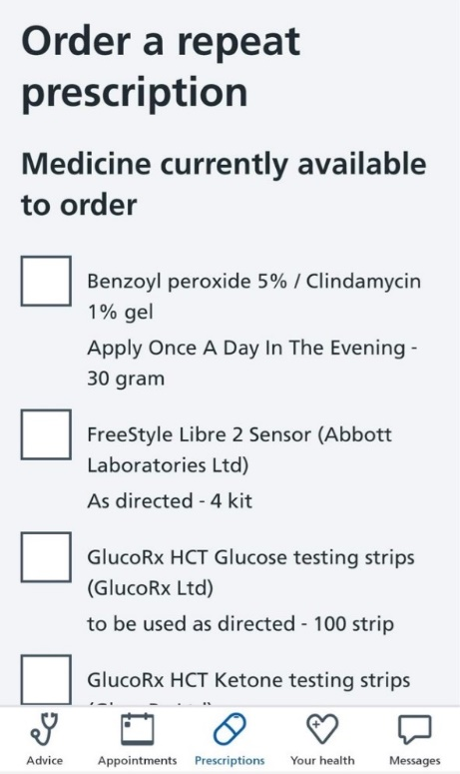

- If needed, include a note for your GP (e.g. if you are going on holiday and would like to request extra medication to last you while you are away) and click ‘Continue’.

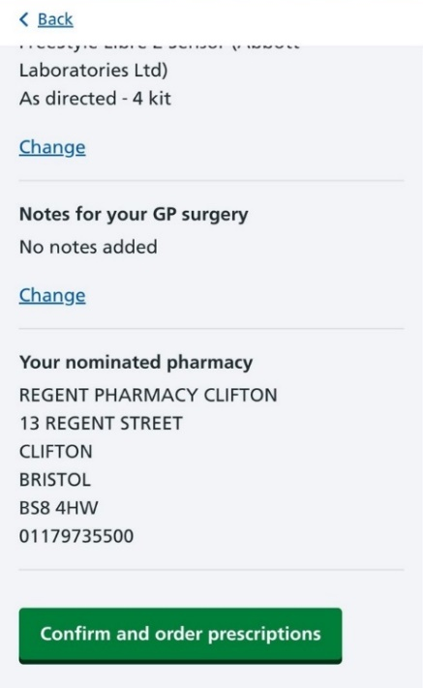
- Review what you’ve selected and click ‘Confirm and order prescriptions’, which will then be sent to your GP to approve.

Once you have ordered your prescription, it will either say ‘Waiting for GP approval’, ‘Undetermined’ or ‘Order approved by GP’. You can contact your chosen pharmacy or GP to find out when the medicine will be ready for collection.

Viewing your medical health records

- Select ‘Your Health’ in the NHS App navigation bar.
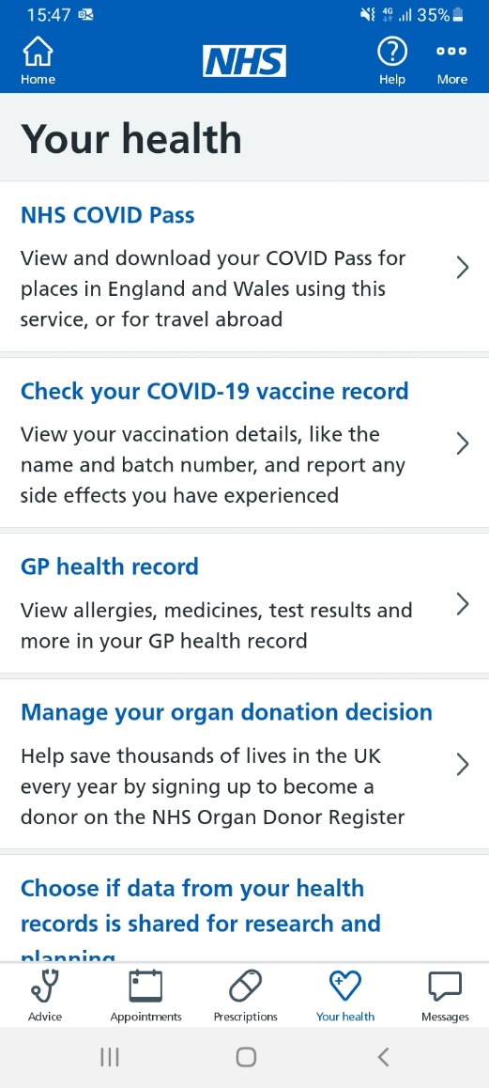

- Select the option you require. You can:
- View your NHS COVID-19 pass
- Check your COVID-19 vaccine record
- View your GP health record
- Manage your organ donation decision.

Additional support

AbilityNet – www.abilitynet.org.uk/
A UK charity supporting people of any age and disability to access digital technology. AbilityNet has free online resources and a network of 300 community-based volunteers to help people use various devices.

Learn My Way – www.learnmyway.com/
A website with over 30 free online courses for beginners to learn digital skills. Courses cover a broad range of topics, from getting familiar with your device to using office programmes and managing your money online.

Digital Unite - www.digitalunite.com/
Digital Unite provides e-learning courses and resources for staff and volunteers to become Digital Champions to feel confident supporting others with digital support. They also have over 400 how-to guides, which cover many digital topics, written by subject matter experts and updated regularly.

NHS account help and support - www.nhs.uk/nhs-app/nhs-app-help-and-support/
Everything you need to know about your NHS account and the NHS App, to help you access NHS services online.

Patient Access support - https://support.patientaccess.com/
Search for help, view video tutorials and seek technical support.

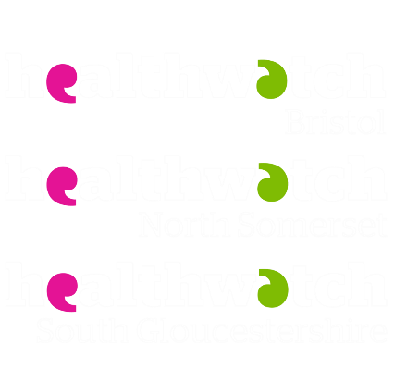
Version 3 – Spring 2023
Healthwatch BNSSG
The Sion Building
Crown Glass Place
Nailsea
BS48 1RB

t: 03300 553251
e: admin@healthwatchbnssg.co.uk
Healthwatch Bristol, North Somerset & South Gloucestershire

Version 1

